Name: Cuyugan, Ken Lester C. | Date Performed:AUGUST 30, 2022
Course/Section: CPE 323-CPE31S22 | Date Submitted:AUGUST 30, 2022
Instructor: ENGR. JONATHAN TAYLAR | Semester and SY: 1ST SEM, 2022-2023
Activity 3: Install SSH server on CentOS or RHEL 8
- Objectives:
  - Install Community Enterprise OS or Red Hat Linux OS
  - Configure remote SSH connection from remote computer to CentOS/RHEL-8
- Discussion:

CentOS vs. Debian: Overview
CentOS and Debian are Linux distributions that spawn from opposite ends of the candle.
CentOS is a free downstream rebuild of the commercial Red Hat Enterprise Linux distribution where, in contrast, Debian is the free upstream distribution that is the base for other distributions, including the Ubuntu Linux distribution.
As with many Linux distributions, CentOS and Debian are generally more alike than different; it isn’t until we dig a little deeper that we find where they branch.

CentOS vs. Debian: Architecture
The available supported architectures can be the determining factor as to whether a distro is a viable option or not. Debian and CentOS are both very popular for x86_64/AMD64, but what other archs are supported by each?
Both Debian and CentOS support AArch64/ARM64, armhf/armhfp , i386 , ppc64el/ppc64le. (Note: armhf/armhfp and i386 are supported in CentOS 7 only.)
CentOS 7 additionally supports POWER9 while Debian and CentOS 8 do not. CentOS 7 focuses on the x86_64/AMD64 architecture with the other archs released through the AltArch SIG (Alternate Architecture Special Interest Group) with CentOS 8 supporting x86_64/AMD64, AArch64 and ppc64le equally.
Debian supports MIPSel, MIPS64el and s390x while CentOS does not. Much like CentOS 8, Debian does not favor one arch over another —all supported architectures are supported equally.

CentOS vs. Debian: Package Management
Most Linux distributions have some form of package manager nowadays, with some more complex and feature-rich than others.
CentOS uses the RPM package format and YUM/DNF as the package manager.
Debian uses the DEB package format and dpkg/APT as the package manager.
Both offer full-feature package management with network-based repository support, dependency checking and resolution, etc.. If you’re familiar with one but not the other, you may have a little trouble switching over, but they're not overwhelmingly different. They both have similar features, just available through a different interface.

Task 1: Download the CentOS or RHEL-8 image (Create screenshots of the following)
- Download the image of the CentOS here: http://mirror.rise.ph/centos/7.9.2009/isos/x86_64/
- Create a VM machine with 2 Gb RAM and 20 Gb HD.
- Install the downloaded image.
- Show evidence that the OS was installed already.
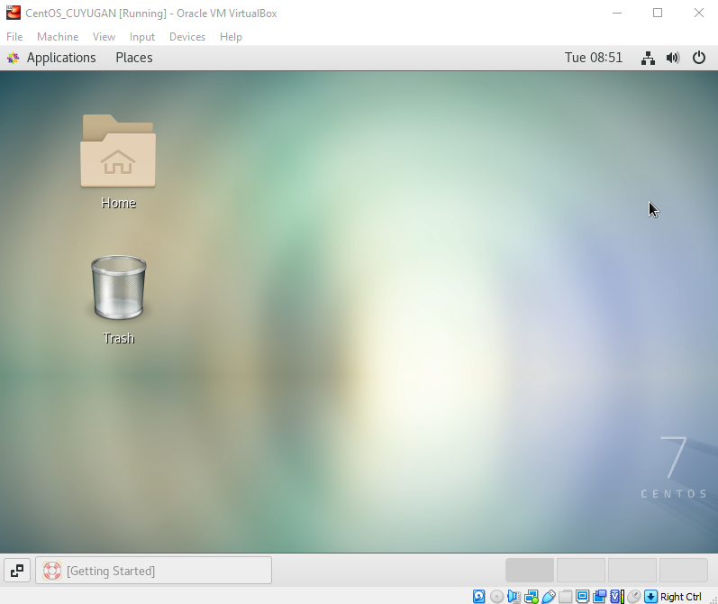

Task 2: Install the SSH server package openssh
- Install the ssh server package openssh by using the dnf command:
$ dnf install openssh-server
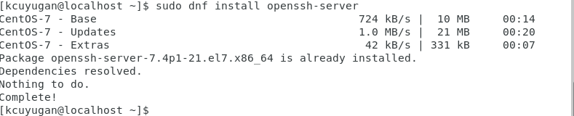

- Start the sshd daemon and set to start after reboot:
$ systemctl start sshd
$ systemctl enable sshd
- Confirm that the sshd daemon is up and running:
$ systemctl status sshd
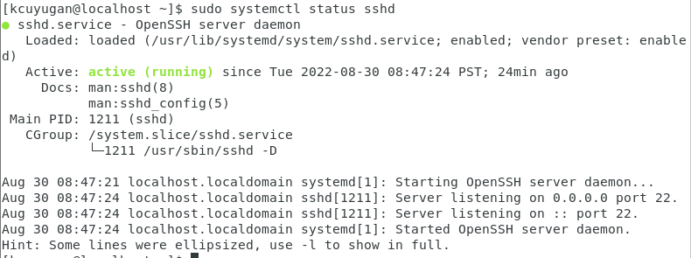
- Open the SSH port 22 to allow incoming traffic:
$ firewall-cmd --zone=public --permanent –add-service=ssh
$ firewall-cmd –reload

- Locate the ssh server man config file /etc/ssh/sshd_config and perform custom configuration. Every time you make any change to the /etc/ssh/sshd-config configuration file reload the sshd service to apply changes:
$ systemctl reload sshd
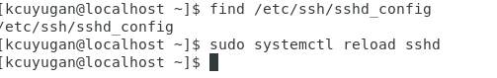

Task 3: Copy the Public Key to CentOS
- Make sure that ssh is installed on the local machine.
- Using the command ssh-copy-id, connect your local machine to CentOS.
- On CentOS, verify that you have the authorized_keys.

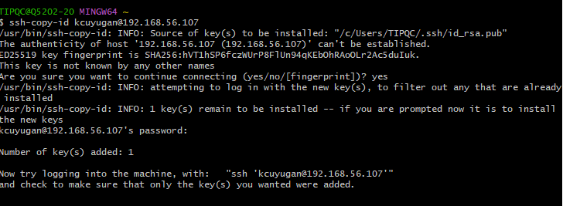

Task 4: Verify ssh remote connection
- Using your local machine, connect to CentOS using ssh.
- Show evidence that you are connected.
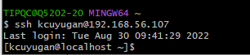

Reflections:
Answer the following:
  - What do you think we should look for in choosing the best distribution between Debian and Red Hat Linux distributions?
- I think choosing the best distribution between debian and red hat linux distributions Is depending on what are the tools requirement.
  - What are the main diffence between Debian and Red Hat Linux distributions?
- The main difference between debian and red hat linux distributions is package management systems and tools.

